DSA Week One Labs

(Deadline Upload on group leader Git before next theory Class)

Work in Groups of Max 5 Members (22 Marks)

Study week one notes and:

- Demonstrate a test on the space limit of data types by writing a C++ program containing variables of data types char, short and int both signed and unsigned for every data type and assign values that overflow and underflow the datatype memory limit. Describe the errors in your output. (12 marks)
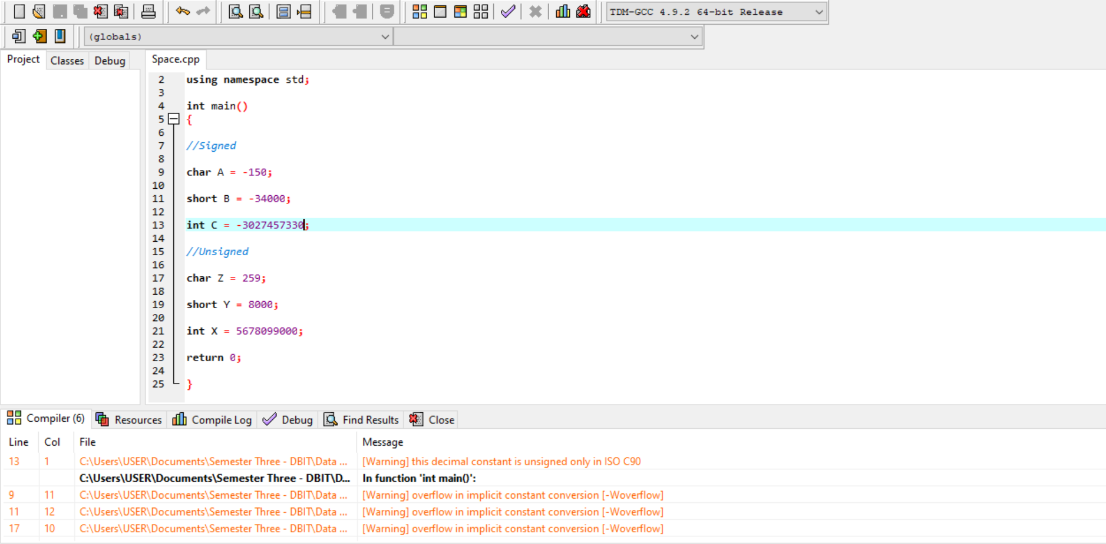
Signed:
- char – It is an underflow because, we declared and initialized char as -150 and it is supposed to be in the range of -128 to 127 therefore when executed an error was brought up since some values are under their limit.

- short – It is an underflow because, we declared and initialized short as -34000 and it is supposed to be in the range of -32768 to 32767 therefore when executed an error was brought up since some values are under their limit.

- int – It is an underflow because, we declared and initialized int as -3027457330 and it is supposed to be in the range of -2147483648 to 2147483648 therefore when executed an error was brought up since some values are under their limit.

Unsigned:
- char – It is an overflow because, we declared and initialized char as 259 and it is supposed to be in the range of 0 to 255 therefore when executed an error was brought up since some values are over their limit.

- short – It is an overflow because, we declared and initialized short as 8000 and it is supposed to be in the range of 0 to 65535 therefore when executed an error was brought up since some values are over their limit.

- int – It is an overflow because, we declared and initialized int as 5678099000 and it is supposed to be in the range of 0 to 4294967295 therefore when executed an error was brought up since some values are over their limit.

- Implement the code in the week one exercise (last slide on notes) generate and explain the output (10 marks)
Two things that are occurring here, array parameters being adjusted to pointer parameters, and array arguments being regenerate to pointer arguments. These are 2 quite totally different mechanisms, the primary is an adjustment to the particular variety of the parameter, whereas the opposite may be a customary conversion that introduces a brief pointer to the primary part.

